Pre K 4 Supply List
2021-2022
- 1 - 2 inch White Binder (Hard cover with front clear sleeve)
- 30 clear page protector sheets
- 2 – bounty Large roll Paper Towels
- 2 – Lysol Dual Action wipes or Clorox Wipes (large container)
- 2 – 8 count boxes of Crayola crayons (primary colors) not large
- 2 – 24 count Crayola crayons
- 1 – Crayola washable markers (8 count primary colors)
- 1 pack – Elmer’s “Jumbo” Glue sticks
- 1 - Elmer’s white glue
- 1– quart size “zippered baggies”
- 1- gallon size zippered baggies
- 1 – plastic 2 pocket folders without clasp or pictures (no black)
- 1 – Prange “8” Watercolors (primary colors)
- 2 – Unscented Tissues (box)
- 1 – Wet wipe
- 2 – Can of Lysol
- 1 – Can of Shaving Cream
- 1 – 4 pack of Playdough (primary colors)
- 1- chair storage pocket chart 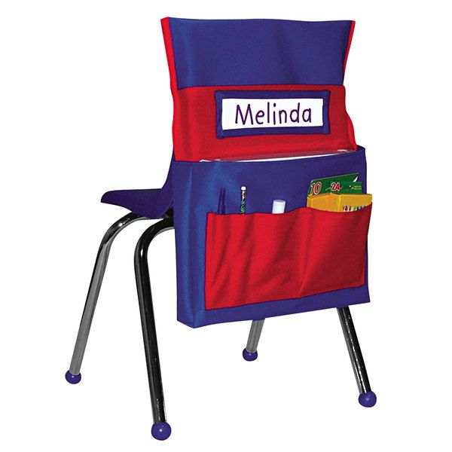amazon, walmart, office depot
Standard Nap Mat (full time students only) NO SLEEPING BAG MATS
Change of clothes labeled in a ziplock
For cubby - please bring small travel pillow and small blanket or beach towel for nap time, cubby space is very small.
No need to label individual supplies as all supplies are shared except for 2” white binder (Only label binder Please)

