ST. Patrick Interparish School
Return to School Plan

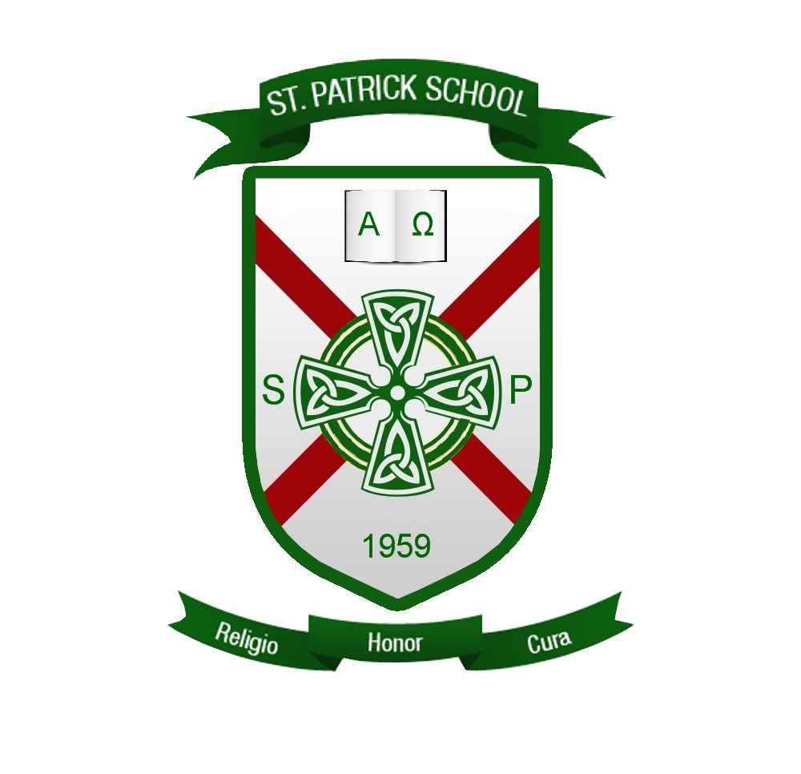

Mission Statement
St. Patrick Catholic School fosters religion, respect, and responsibility through a Christ centered curriculum based on academic excellence, Catholic tradition and service to the community.

Introduction
We have created this plan to aid in navigating the reestablishment of our school where employees, students, and families feel safe and to reduce the impact of COVID-19 conditions upon returning to our schools. The guidelines referenced in this plan are based on guidance from the Centers for Disease Control and Prevention (CDC), Department of Health (DOH), and World Health Organization (WHO). We continue to look at best practices in education while listening to the recommendations being made by the Department of Education (DOE), Office of Early Learning (OEL), the National Catholic Education Association (NCEA), and the Florida Catholic Conference School Executive Committee (FCCSEC) and Accreditation Committee (FCCA). Regular updates will be made to this plan based on information provided by all the organizations mentioned above, and applicable federal, state and local agencies.

Our priorities are:

- Safety: Mitigating and slowing the growth of COVID-19 in the context of a return to work and schools. Understanding that there is inherent risk in returning from social distancing while in a pandemic, we also understand that we are part of a societal decision that accepts balancing COVID-19 risk against the need for life to continue.
- Presence: Keeping school open daily. We do not want to burden parents with challenging schedules that require them to stay home and out of work - we want our students at school in their cohort for the full day.
- Growth: Despite limitations, we want our children to continue their academic progress at grade level in their faith and in all core academic standards.

This document will be updated regularly. The school principal will share the updated document on the school website and distribute the updated version to parents via the school information system.

Table of Contents
Cleaning and Sanitizing 5
Daily Operations/Logistics 5
COVID-19 Daily Screenings and Forms 6
Visitors and Volunteers 6
Cafeteria 7
Classrooms 7
Training Schedule 7
Communications 8
Instructional Continuity Plan (ICP) 8
Extra-Curricular Activities 8

Cleaning and Sanitizing
- Specific Measures
  - Frequency
    - All common areas such as the Cafeteria, hallways, gym, etc. will be cleaned, disinfected, and sanitized daily
    - All classrooms to include desks, equipment, and supplies will be cleaned, disinfected, and sanitized daily
  - Personnel Responsibility
    - Teachers and aides will be responsible for cleaning and disinfecting classroom supplies and equipment
    - Maintenance staff is responsible for cleaning and disinfecting all after and before school areas
    - Our custodial staff will clean and disinfect all common areas
  - Equipment and Supplies
    - Disinfecting wipes, sanitizing bottles, paper towels, wash rags will be supplied
    - We have also acquired an electrostatic sprayer with bioesque botanical disinfectant to spray the outdoor equipment and bathrooms at periodical intervals throughout the day.
- Room Capacity
  - Each room will max out at 22 students with 1 teacher and 1 aide. The desks will be separated as much as possible with the space provided.
  - Common areas will social distance to the greatest extent possible. We will use staggered dismissals and lunch times.
    - Middle school will dismiss by grade, one class will enter through the inside door, while the other enters through the outside door. Elementary will transition by class only.

Daily Operations/Logistics

- Arrival Procedures- All temperatures recorded above 100.4 will be sent to the clinic for parent pick up. A staff/faculty member will be sent home.
  - For Teachers- All teachers will have temperature checks daily and wear a mask at all times around campus. Only exceptions that will be made are for lecture or discussion time in class.
  - For Students- All students will have temperature checks done daily in homeroom. Tardy students will have their temperatures taken at the front office and then walked to class by our office personnel. A parent must accompany the tardy student to the front office and sign them in.
    - All students will be required to wear masks. We will work diligently with all students to ensure proper wear and care of the masks.
    - When a student is sitting at their desks, the teachers will determine, with social distance guidelines, when it is safe to have a “breathable” moment. When leaving their seat for any reason, a mask will be required.
    - A mask will not be worn during aerobic activity such as PE and recess
  - For Parents/volunteers/visitors- All visitors will be required to wear a mask in the front office. No visitors will be allowed past the front office.
- Daily Health Checks
  - A student or staff member who experiences any changes in health conditions during the day will be sent to the front office for the school nurse to determine status.
- Social Distancing Measures
  - In the Classroom- Desks will be positioned as far apart as possible
  - Outside the Classroom- For common areas, social distancing will be kept with staggered recess, lunches and dismissals from class.
    - Each elementary class will have their own time on the playgrounds as determined by the elementary teachers’ schedules.
    - Only two grades will be in the cafeteria at a time spread out amongst 14 different tables
  - At Mass on Friday, beginning with 8th grade, only one grade at a time will be allowed to attend weekly mass. The remaining classes will watch mass virtually with their teacher. When time for communion, students will walk over, with their teacher, in social distance lines and receive communion. Outside visitors will be determined by the amount of room taken up by our students. This will ensure we keep with the mandated 50% of the church capacity.

COVID-19 Daily Screenings and Forms
- Temperature Checks
  - If a child is sick, please keep them at home until they recover
  - Students or staff suspected of COVID-19 will be asked to be picked up or leave campus.
- Positive COVID 19 results
  - The superintendent of schools at the diocese is immediately notified
  - The superintendent, in coordination with the principal and the most recent Florida Department of Health (FLDOH) regulations will determine if or when quarantine and/or return is necessary or permissible.
  - When determinations are made about who/when certain groups or individuals should quarantine, a notification will be sent to the community within 24 hours.
  - Since, the FLDOH must update their website to stay up to date on current conditions and regulations I have included their link https://floridahealthcovid19.gov

- Isolation Room
  - The school clinic will be our isolation room until the student can be picked up.
  - The school nurse will monitor the isolation room
  - Confidentiality Issues
      - Please be aware that the medical condition of any individual is protected by privacy laws.

Visitors and Volunteers
- Specific Protocols
  - Visitors and Volunteers must drop items off at the front office. Each visitor must wear a mask. They will not be permitted to travel around the campus.
  - The front office has social distance markers on the floor. Please maintain the 6ft distance between visitors.
  - Currently no activities are permitted that require visitors or volunteers.

Cafeteria
- Daily Operations
  - Food Ordering and Delivery/Pick-up
    - Our school has a company that completes our cafeteria operations. Their plan will be added to this one when it is received.
  - Food Preparation
    - See above
    - See above
  - Food Distribution
    - For those eating hot lunch, social distance markers are located on the cafeteria floor to maintain proper distance in line.
    - Cafeteria times will be staggered that will put only two classes in the cafeteria at one time. Students will have plenty of space available. This will ensure the appropriate space required for social distancing.
  - Additionally, all students will be required to use their own water bottles. Please ensure their names on the water bottles. Water fountains that have the built-in bottle filler will be the only ones allowed for use. The water fountains with mouth receptacles will be turned off and covered.
Classrooms
- Desk spacing will be to the greatest extent possible for the space provided
- Cleaning Protocols
  - Between classes, desks will be sprayed with disinfectant and wiped down
  - After school, a thorough cleaning, disinfecting and sanitizing will be accomplished by the teachers
- Class dismissals for middle school will be staggered for each grade. Inside and outside doors will be utilized so that one class will be in the hallways at a time.
- Lockers will be separated so that each grade is spread throughout the hallway. They will be provided specific times, by grade, to go to their lockers.
- During elementary transitions, one class at a time will transfer.

Training Schedule
- During pre-planning each one of the groups below will be provided training on the expectations of cleaning, disinfecting, and sanitizing the areas they are responsible for.
  - Maintenance Staff
  - Cleaning Crew
  - Faculty and Staff
- Orientation for students about new school policies/procedures will occur in homeroom on Day 1 and then as needed for reminders
- All training will be hands on demonstration, practice and perform.

Instructional Continuity Plan (ICP)
- ICP Review/Update Committee
  - We will continually review our distance learning procedures.
  - The committee will consist of the principal, 1 staff member, 1 PreK teacher, 1 elementary teacher, and 1 middle school teacher.
  - We have gathered feedback from all stakeholders will determine how to move forward.
    - Google classroom will be used for homework communication and happenings in the classroom.
    - If distance learning is required again, Google meets will be used for live sessions with the teachers
    - All students Kindergarten through 8th grade will be shown how to access Google classroom. Parents will be supplied with their child’s google email and password.
- Beginning of Year Assessment/Data Committee
  - 3rd through 8th grades will be administered both the BCN Terra Nova and the Star reading test.
  - We will work closely with our Title I teachers to develop individual plans for any required Student Gap Recovery Plan

Extra-Curricular Activities
      - After School Care will be separated into PreK-K, 1st and 2nd grade, 3rd and 4th grade, 5th and 6th grade, and 7th and 8th grade
      - After School Clubs and Activities will be postponed until at least the end of the first quarter.
      - Sports programs will be postponed until at least the end of the first quarter.
      - Pick up will be separated throughout the campus to allow for proper distance.
        - PreK3 and PreK4 and their siblings along with kindergarten only will be picked up in the main entrance loop
        - Kindergarten with older siblings will be released at 2:45 and will stay in their classrooms until called out. They will be picked up in the car loop
        - Elementary students 1st through 5th will be picked up in the car loop. They will stay in their classrooms until called out.
        - All middle school students, and their siblings will be picked up outside the church entrance. Please follow the signs.
        - At this time, please do not walk up for pick up, please use the car loop only.

